Data Science lab

SET 4

1. Create a 1 Dimensional array with 20 elements in float data type and use arange to fill the
array with odd numbers from 1.
(i) Reshape array into 5X4 matrix
(ii) Display the elements of rows 2 to 5 and columns 1 to 3
(iii) Display the elements of 2 nd and 3 rd column
(iv) Display last 2 elements of last row

Program:

import numpy as np
arr=np.arange(1,21,1,dtype=float)
print("1D array with 20 elements:\n",arr)

odd=np.arange(1,20*2,2)
print("Odd Array : ",odd)

mat=odd.reshape(5,4)
print("Reshape array to 5x4 matrix:\n",mat)

print("Display the elements of rows 2 to 5 and columns 1 to 3:")
print(mat[1:5 , 0:3])

print("Display the elements of 2nd and 3rd column:")
print(mat[:,1:3])

l=mat[-1]
print("Last row:",l)
print("Display last 2 elements of last row:")
print(l[-2:])

Output:
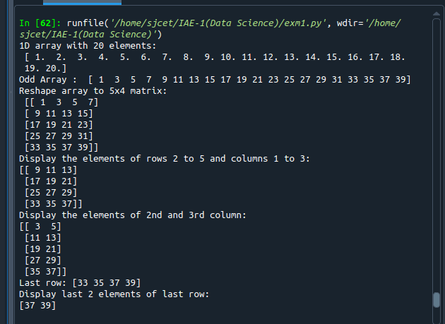

2. Write a program to perform bubble sort on a given set of elements

Program:

def bubbleSort(arr):
for i in range(n - 1):
for j in range(0, n - i - 1):
if arr[j] > arr[j + 1]:
arr[j], arr[j + 1] = arr[j + 1], arr[j]

arr = []
n = int(input("Enter limit :"))
print("Enter elements :")
for i in range(0,n):
arr.append(int(input()))

bubbleSort(arr)
print("Sorted array is:")
for i in range(len(arr)):
print("% d" % arr[i])

Output:

